CSS ASSIGNMENT

1.Write a HTML and **Inline CSS** to get the Output as shown below

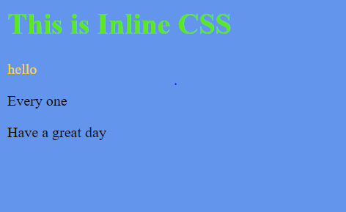

2.Write a HTML and **Internal CSS** to get the Output as shown below

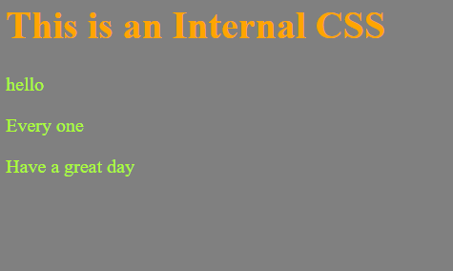

3. Write a HTML and **External CSS** to get the Output as shown below

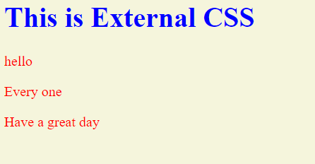

4. Write a HTML code and use **ID and Class** selector to get the Output as shown below

